**OBJECT ORIENTED PROGRAMMING**

**LAB BASED PROJECT REPORT**

On

**FUNCTIONAL HALL MANAGEMENT SYSTEM**

Submitted in partial fulfillment of the

Requirements for the award of the Degree of

**Bachelor of Technology**

In

**ELECTRONICS AND COMMUNICATION ENGINEERING**

By

ROHINI PANDIRI(2100031934)

**UNDER THE GUIDENCE OF**

P.S.G. Aruna Sri (Ph.d)

(asscociate professor)

**K.L. UNIVERSITY**

**Green fields, Vaddeswaram-522502,**

**2021-22**

**ELECTRONICS AND COMMUNICATION ENGINEERING**

**K L University**

**Green Fields Vaddeswaram, Guntur district-522 502**



**CERTIFICATE**

This is to certify that the course based project titled **“FUNCTIONAL HALL MANAGEMENT SYSTEM”** being submitted by **K.NAVEENA (150040346), T.NAGESWARA RAO (150030891)** in partial fulfillment for the award of degree of **Bachelor of Technology** in department of Electronics and communication engineering is a record of bonofied work carried out by them under my guidance during the academic year **2016-2017**  and it has been found worthy of acceptance according to the requirements of the university.

**UNDER THE GUIDENCE OF:**

**Smt.P.G.S.Aruna sri**

**DECLARATION**

We declare that the project work entitled ”FUNCTIONAL MANAGEMENT SYSTEM ”was carried out by us during MARCH 2022, and this work is not the same as that of any other and has not been submitted for award of any other degree/diploma .

Place: VIJAYAWADA

Signature of the Student

DATE:

**INDEX**

|  |  |
| --- | --- |
| CONTENT | Page NO. |
| ACKNOWLEGEMENTS | **4** |
| ABSTRACT | **5** |
| Introduction | **6** |
|  |  |
| Objective of the project | **8** |
|  |  |
| Program for functional hall management system | **9-14** |
|  |  |
| Outputs screenshots | **15-17** |

**ACKNOWLEDGMENT**

The satisfaction that accompanies that the successful completion of any task would be incomplete without the mention of people whose ceaseless cooperation made it possible whose constant guidance and encouragement crown all efforts with success.

We are grateful to our project based Lab guide P.S.G. Aruna Sri for the guidance, inspiration and constructive suggestions that helped us in the completion of this project.

We express our gratitude to **Dr.A.S.C.S.Sastry** Head of the Department for Electronics & Communication Engineering for providing us with adequate facilities, ways and means by which we are able to complete this project work.

We would like to place on record the deep sense of gratitude to the Honourable Vice Chancellor, K L University for providing the necessary facilities to carry the concluded project work.

Last but not the least, we thank all Teaching and Non-Teaching Staff of our department and especially my classmates and my friends for their support in the completion of our project work.

**PROJECT BATCH**

**ROHINI PANDIRI 2100031934**

**ABSTRACT**

A **convention center** is a large building that is designed to hold a**convention** where individuals and groups gather to promote and share common interests. Convention center typically offer sufficient floor area to accommodate several thousand attendees. Very large venues, suitable for major trade shows, are sometimes known as exhibition centres Usually very broadly defined as "the science of sound Acoustics is the interdisciplinary science that deals with the study of all mechanical waves in gases, liquids, and solids including topics such as vibration sound ultrasound and infrasound. Strong echoes and focusing lead to a non- uniform sound level within the room which is not desirable These features of the auditorium design scatters, convex surfaces on balcony fronts, absorption materials, carpet. Intimacy implies a short time between the first reflection of sound to the ear and the direct sound from the source Sound level of the source needs to be distinctly higher than the background sound. This promotes good speech intelligibility This keeps the background noise level down Thick heavy walls and doors help to reduce the background noise. Seals on doors are important It is also important to reduce noise from air handling systems, walking on floors and also talking outside the room Sound absorbing acoustical panels and soundproofing materials are used to eliminate sound reflections to improve speech intelligibility, reduce standing waves and prevent comb filtering. A wide variety of materials can be applied to walls and ceilings depending on your application and environment. These materials vary in thickness and in shape to achieve different absorption ratings depending on the specific sound requirements.

**FUNCTIONAL HALL MANAGEMENT SYSTEM**

**INTRODUCTION:**

A convention center is a large building that is designed to hold a convention, where individuals and groups gather to promote and share common interests. Convention centers typically offer sufficient floor area to accommodate several thousand attendees a convention, in the sense of a meeting, is a gathering of individuals who meet at an arranged place and time in order to discuss or engage in some common interest. The most common conventions are based upon industry, profession, and fandom. Trade conventions typically focus on a particular industry or industry segment, and feature keynote speakers, vendor displays, and other information and activities of interest to the event organizers and attendees. Professional conventions focus on issues of concern to the profession and advancements in the profession. Such conventions are generally organized by societies or communities dedicated to promotion of the topic of interest. Fan conventions usually feature displays, shows, and sales based on pop culture and guest celebrities. Science fiction conventions traditionally partake of the nature of both professional conventions and fan conventions, with the balance varying from one to another. Conventions also exist for various hobbies, such as gaming or model railroads.

Conventions are often planned and coordinated, often in exacting detail, by professional meeting and convention planners, either by staff of the convention's hosting company or by outside specialists. Most large cities will have a convention center dedicated to hosting such events. The term MICE—meetings Incentives Conventions and Exhibitions—is widely used in Asia as a description of the industry. The Convention ("C") is one of the most dynamic elements in the M.I.C.E. segment. The industry is generally regulated under the tourism sector.

In the technical sense, a convention is a meeting of delegates or representatives. The 1947 Newfoundland National Convention is a classic example of a state-sponsored political convention. More often, organizations made up of smaller units, chapters, or lodges, such as labor unions, honorary societies, and fraternities and sororities, meet as a whole in convention by sending delegates of the units to deliberate on the organization's common issues This also applies to a political convention, though in modern times the common issues are limited to selecting a party candidate or party chairman. In this technical sense, a congress, when it consists of representatives, is a convention. The British House of Commons is a convention, as are most other houses of a modern representative legislature. The National Convention or just "Convention" in France comprised the constitutional and legislative assembly which sat from September 20, 1792 to October 26, 1795. The governing bodies of religious groups may also be called conventions, such as the General Convention of the Episcopal Church USA and the Southern Baptist Convention.

**OBJECTIVE OF PROJECT:**

1. CHAIRS
2. ELECTRICAL LIGHTS
3. DOLBY SOUNDS
4. NORMAL ROOMS
5. VEHICLES
6. A/C ROOMS
7. NON AC ROOMS

**PROGRAMM FOR FUNCTIONALHALL MANGEMENT SYSTEM**

import java.util.Scanner;

class Hall

{

int x,y,decor,food;

String Name;

double a=80000.0,b=10000.0,c=20000.0,e=30000.0,f=5000.0,g=3000.0,h=2000.0;

Scanner input=new Scanner(System.in);

void display()

{

System.out.println("\t\t\t===============================");

System.out.println("\t\t\t WELCOME TO VAMSI PALACE");

System.out.println("\t\t\t===============================");

System.out.println("The function halls available in the city are listed below:");

System.out.println("1.Hall 1");

System.out.println("2.Hall 2");

System.out.println("3.Hall 3");

System.out.println("Select your choice");

x=input.nextInt();

if(x==1)

{

System.out.println("enter the name on which hall is to be booked");

Name=input.next();

System.out.println("the amount for booking the hall is Rs.20,000/-");

System.out.println("select the type of function to be organised in hall 1:");

System.out.println("1.Marriage");

System.out.println("2.Convention Hall");

System.out.println("3.Birthdays");

System.out.println("4.family functions");

System.out.println("enter the option");

y=input.nextInt();

System.out.println("select the desired things for decoration from list below:");

System.out.println("1.Natural flowers and premium fabric draping along with lightings");

System.out.println("2.candles,stylish linen and glassware,floral designs");

System.out.println("3.Dance area and bar");

decor=input.nextInt();

System.out.println("select the food");

System.out.println("1.multi-cuisine");

System.out.println("2.non-vegetarian");

System.out.println("3.vegetarian");

System.out.println("enter the option");

food=input.nextInt();

}

if(x==2)

{

System.out.println("enter the name on which hall is to be booked");

Name=input.next();

System.out.println("the amount for booking the hall is Rs.30,000/-");

System.out.println("select the type of function to be organised in hall 1:");

System.out.println("1.Marriage");

System.out.println("2.cultural functions");

System.out.println("3.Birthdays");

System.out.println("4.family functions");

System.out.println("enter the option");

y=input.nextInt();

System.out.println("select the desired things for decoration from list below:");

System.out.println("1.Natural flowers and premium fabric draping along with lightings");

System.out.println("2.candles,stylish linen and glassware,floral designs");

System.out.println("3.Dance area and bar");

decor=input.nextInt();

System.out.println("select the food");

System.out.println("1.multi-cuisine");

System.out.println("2.non-vegetarian");

System.out.println("3.vegetarian");

System.out.println("enter the option");

food=input.nextInt();

}

if(x==3)

{

System.out.println("enter the name on which hall is to be booked");

Name=input.next();

System.out.println("the amount for booking the hall is Rs.25,000/-");

System.out.println("select the type of function to be organised in hall 1:");

System.out.println("1.Marriage");

System.out.println("2.cultural functions");

System.out.println("3.Birthdays");

System.out.println("4.family functions");

System.out.println("enter the option");

y=input.nextInt();

System.out.println("select the desired things for decoration from list below:");

System.out.println("1.Natural flowers and premium fabric draping along with lightings");

System.out.println("2.candles,stylish linen and glassware,floral designs");

System.out.println("3.Dance area and bar");

decor=input.nextInt();

System.out.println("select the food");

System.out.println("1.multi-cuisine");

System.out.println("2.non-vegetarian");

System.out.println("3.vegetarian");

System.out.println("enter the option");

food=input.nextInt();

}

}

void payment()

{

if(y==1||y==2||y==3||y==4)

{

System.out.println("The hall is booked by the name"+Name);

System.out.println("the amount to be paid for organising is" +a);

if(decor==1)

{

System.out.println("the extra amount to be paid for decorations is" +b);

if(food==1)

{

System.out.println("the amount for variety of food is" +f);

System.out.println("the total amount is" +(a+b+f));

}

if(food==2)

{

System.out.println("the amount for variety of food is" +g);

System.out.println("the total amount is" +(a+b+g));

}

if(food==3)

{

System.out.println("the amount for variety of food is" +h);

System.out.println("the total amont is" +(a+b+h));

}

}

if(decor==2)

{

System.out.println("the extra amount paid for decorations is" +c);

if(food==1)

{

System.out.println("the amount for variety of food is" +f);

System.out.println("the total amount is" +(a+c+f));

}

if(food==2)

{

System.out.println("the amount for variety of food is" +g);

System.out.println("the total amount is" +(a+c+g));

}

if(food==3)

{

System.out.println("the amount for variety of food is" +h);

System.out.println("the total amont is" +(a+c+h));

}

}

if(decor==3)

{

System.out.println("the extra amount paid for decorations is" +e);

if(food==1)

{

System.out.println("the amount for variety of food is" +f);

System.out.println("the total amount is" +(a+e+f));

}

if(food==2)

{

System.out.println("the amount for variety of food is" +g);

System.out.println("the total amount is" +(a+e+g));

}

if(food==3)

{

System.out.println("the amount for variety of food is" +h);

System.out.println("the total amount is" +(a+e+h));

}

}

}

}

}

class Functionhall1

{

public static void main(String args[])

{

Hall ob=new Hall();

ob.display();

ob.payment();

}

}

**OUTPUTS**

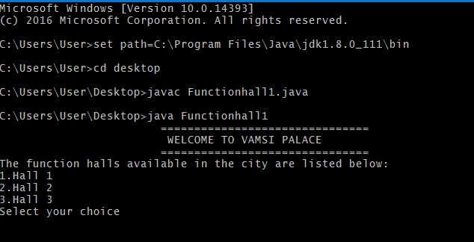

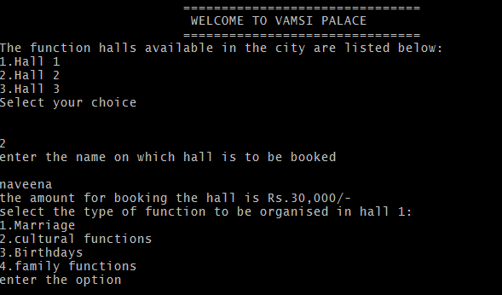

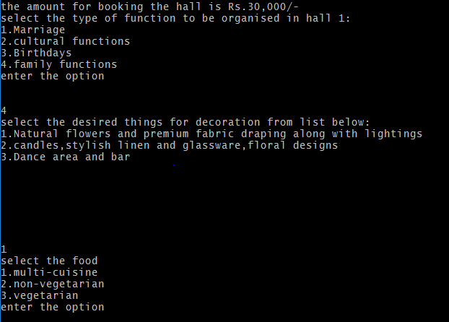

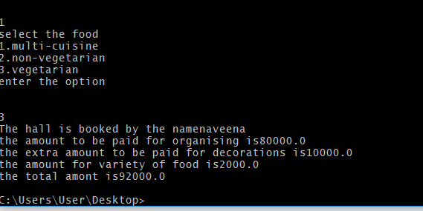

**ROHINI PANDIRI2100031934**